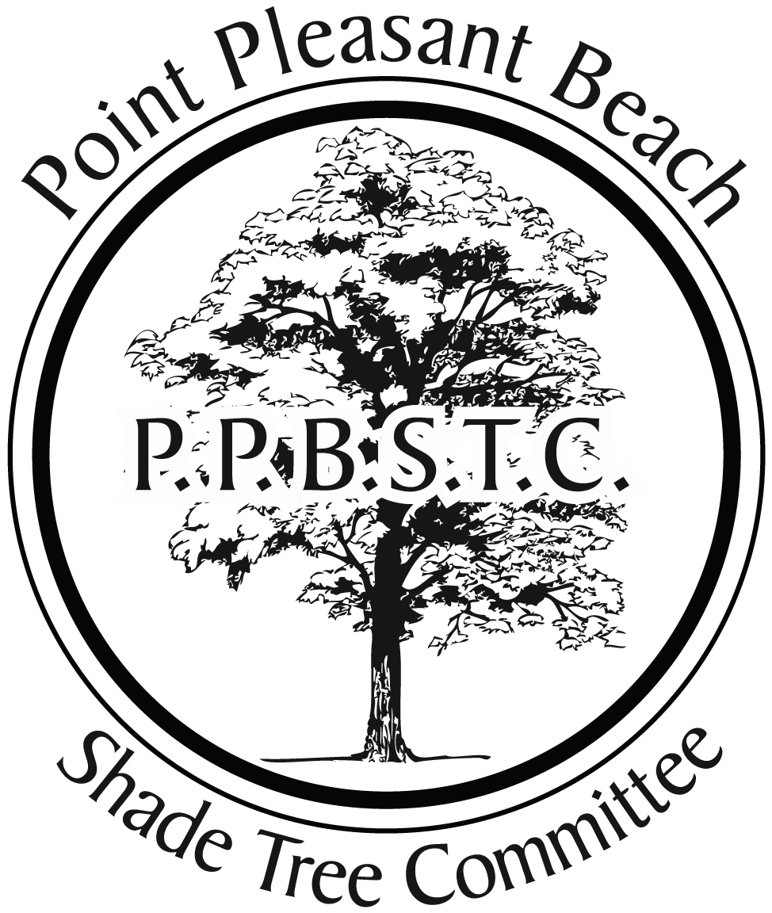
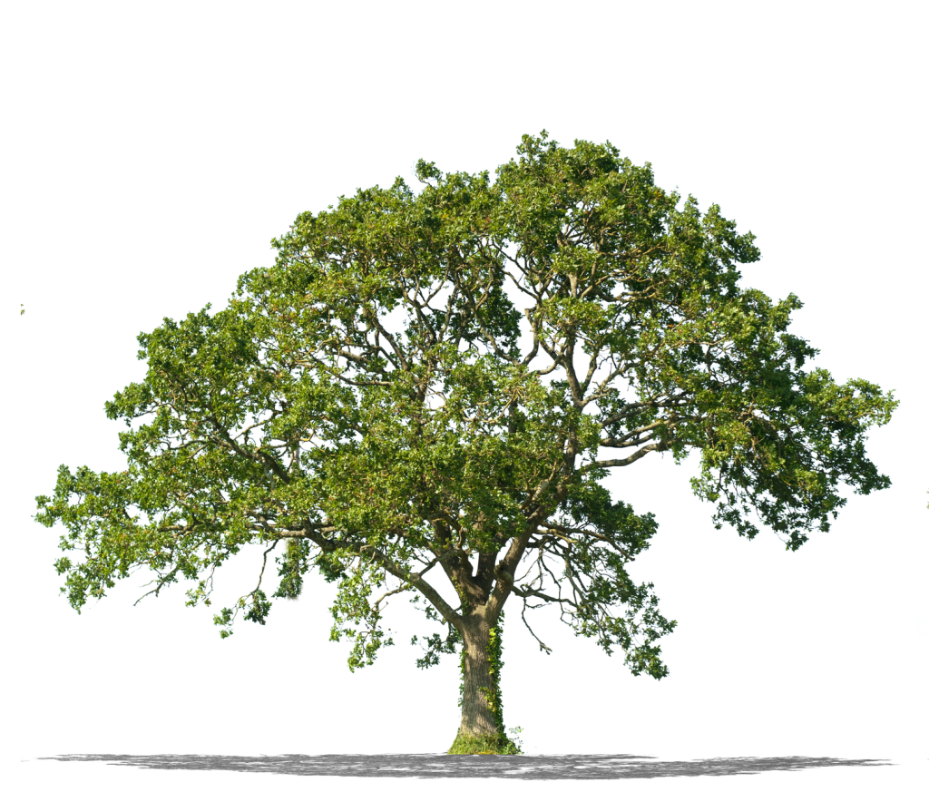

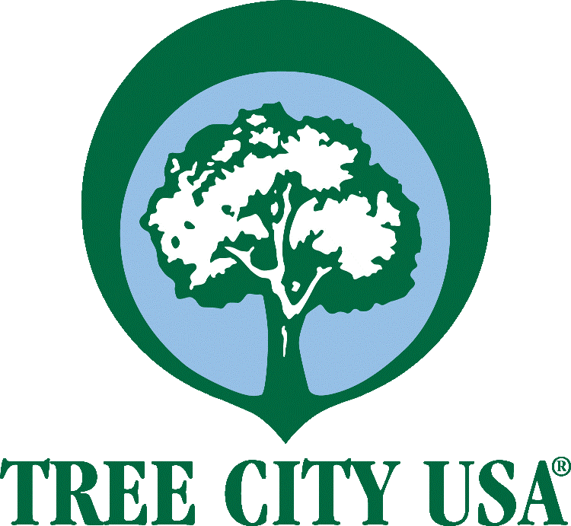
$350
-Includes Delivery & Installation and Gator Bag for watering
-Trees will be 2-2.5” Caliper (roughly 10-12’ Tall) at delivery
-Trees are guaranteed for 1 year with adequate watering
-Order form and checks need mailed to 319 Forman Ave. Point Pleasant Beach for receipt by Monday March 9th
-Planting will take place in April/May
-If you can’t print order form, additional copies will be available at Borough Hall
-Residents may order as many trees for their property as desired
-Residents choose planting location(s)
-Questions – prennerp@gmail.com or call/text Dave Smith at 732-236-4927

Spring 2020 TREE PROGRAM
Point Pleasant Beach is a beautiful town with tree-lined streets. In order to ensure shade for generations to come, the Shade Tree Commission has procured the following pricing for our residents and property owners:

$250 6-7’ at time of planting

-Norway Spruce
-Serbian Spruce
-Fernspray Hinoki Cypress
-Juniper ‘Star Power’

EVERGREEN TREES

Ornamental Flowering Trees
(typically get 25’ tall)

-Ivory Silk Lilac
-Japanese Snowbell
-Kwanzan Cherry
-Jane Magnolia
-Summer’s Tower Redbud

SHADE TREES
(suitable if no over-head wires are present directly overhead of planting location)

-Sugar Maple
-Redpointe Maple
-Valley Forge Elm
-London Plane

