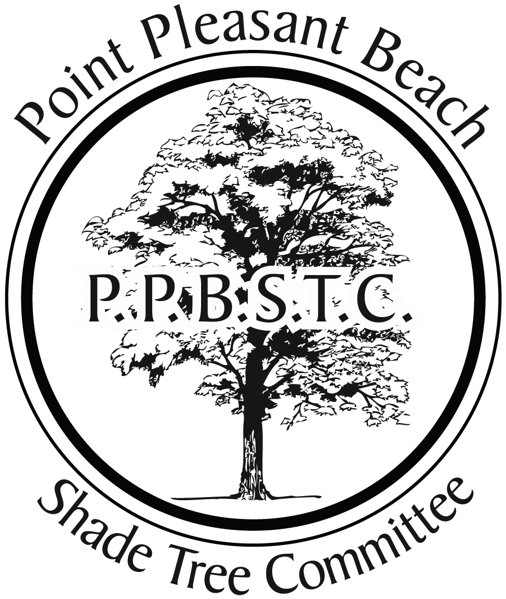

- Planting Guidelines

  - Purchase includes delivery, planting and Gator Bag, homeowners are responsible for care of tree, including staking (if desired), mulching and watering.

  - Once order is placed, the Shade Tree Commission will order a utility mark-out of your property. Based on utility locations, homeowner is responsible for staking location of desired planting. If no markings are completed, tree(s) will be planted in what is deemed the best location by the planter.

  - STC and Borough of Point Pleasant Beach are not responsible for trees and/or homeowner property.

  - Quantities of certain species are limited. If your selection is not available at time of planting, alternatives will be offered. If unacceptable, you may cancel your order.

  - Date of planting: April/May
*Extra Order Forms will be available at Clerk’s Office at Borough Hall
Point Pleasant Beach Shade Tree Commission
Big Beautiful Tree Resident Buying Program-Spring 2020
Resident Name:
Telephone #:
Email Address:
Planting Address:
Tree |  |  | Quantity |  | Unit Price | Total
 |  |  |  |  | TOTAL DUE:
Make check payable to "Big Beautiful Tree" and mail with order form to 319 Forman Avenue, Point Pleasant Beach NJ, 08742
Check and order form must be received by Monday March 9th
Any questions please email:
prennerp@gmail.com or call/text Dave Smith at 732-236-4927

